Pokhara University

Level: Bachelor | Semester –Fall | Year : 2010
Programme: BE |  | Full Marks : 100
 |  | Pass Mark : 45
Course: Electronic Devices |  | Time : 3 hrs

Candidates are required to give their answers in their own words as far as practicable.
The figures in the margin indicate full marks.

Attempt all the questions.

1. | - Is diode a linear device? Find the piecewise linear model of a Silicon diode with I_{s} = 10⁻¹¹ A and η = 1.6 in the vicinity of operating point I_{D} = 1mA.  - What are the equivalent circuit models of PN junction diode? Draw and explain about the piecewise linear model of PN junction. | 8  7
2. | - What is tunneling phenomenon? Describe the V-I characteristics of tunnel diode in brief and mention its applications.  - Determine the range of values of V_{i} that will maintain the Zener diode in the “on” state. Where Rs = 220Ω , R₁= 1.2KΩ, Vz= 20Vand Izm = 60mA in the figure shown below: | 8  7
3. | - Describe the output characteristics of common emitter configuration.  - For the transistor amplifier shown below,  - Draw dc load line  - Operating point  - a.c. load line | 8  7
4. | - the transistor shown in figure has the following h parameter values: h_{ie} = 0.86KΩ , h_{fe} = 140, h_{re} = 1.5x10⁻⁴, h_{oe} = 25μS. find 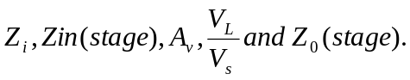  - For the given circuit h_{ie} =1KΩ, h_{re} = 1x10⁻⁴, h_{oe} = 100μΩ, Rc = 1000Ω, Rs = 1000Ω, h_{fe} = 50. Find:  - Current gain (Ai)  - Input (stage) resistance (r_{in})  - r_{in} (stage)  - Voltage gain (Av) | 8  7
5. | - Explain the working operation of n-channel JFET with following conditions:  - V_{GS} = 0V, V_{DS} = some positive value  - V_{GS}<0V  - In the given JFET, the operating point is to be set at I_{D} = 1.5mA and V_{DS} = 10V. The JFET parameters are I_{DSS} = 5mA and V_{P} = -2V. Find the values of R_{S} and R_{D}. Given that V_{DD} = 20V.  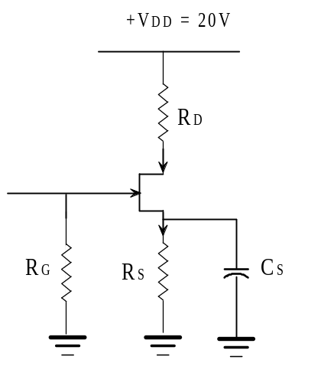 | 8  7
6. | - For the circuit given below find out the output voltage waveform and explain how waveform is drawn?  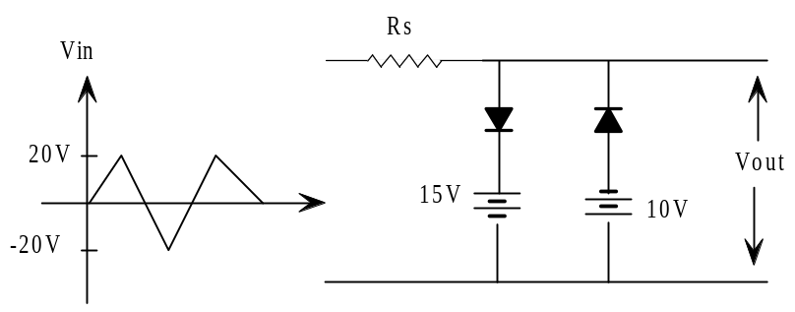  - What is the main purpose of the rectifier? Compare the half wave and full wave rectifier in terms of dc level, efficiency, ripple factor and rms value. | 8  7
7. | Write short notes on (Any Two):  - High frequency t-model  - Depletion type MOSFET  - Ebers-moll equation | 2×5

